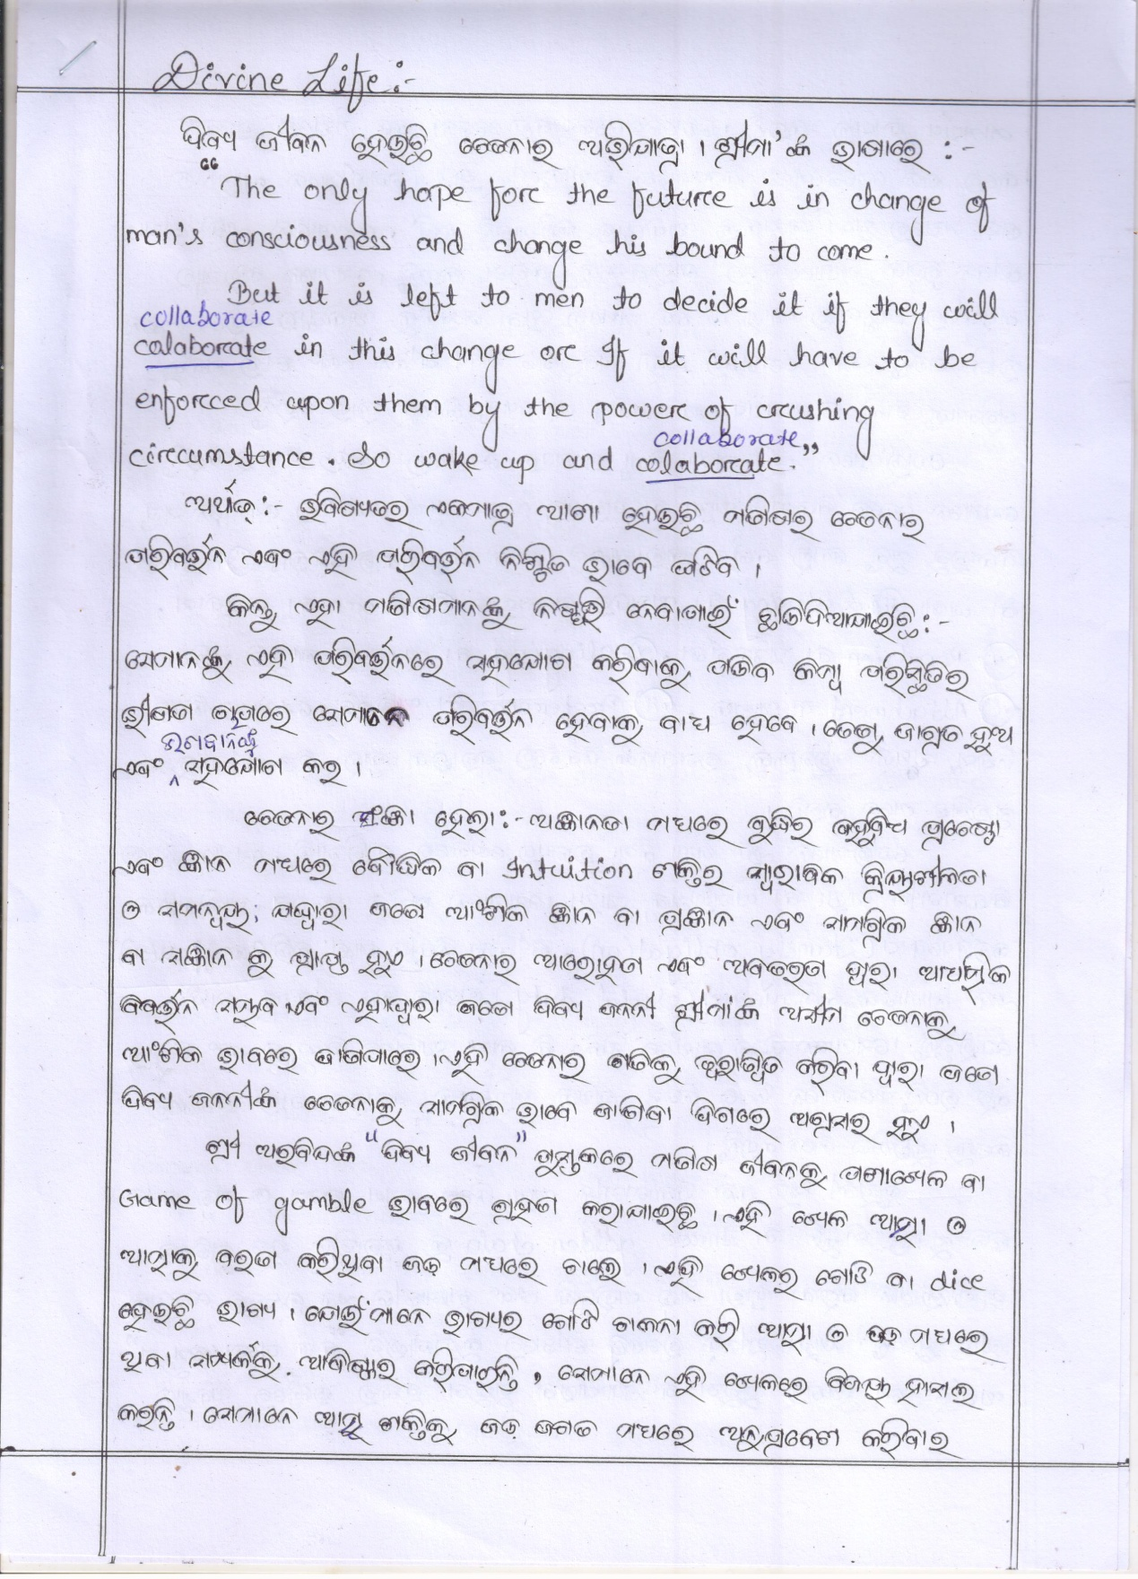

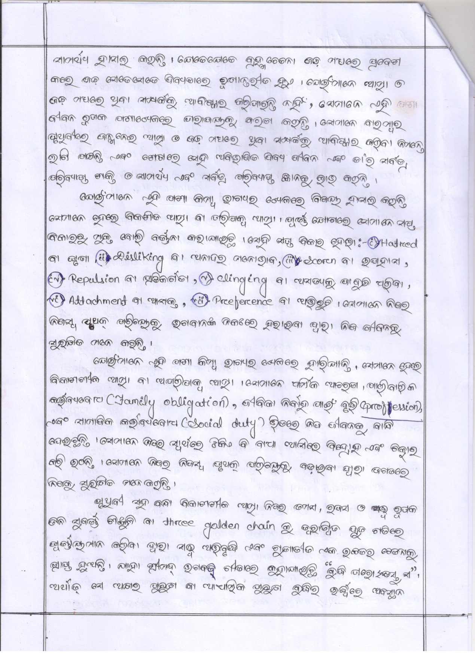

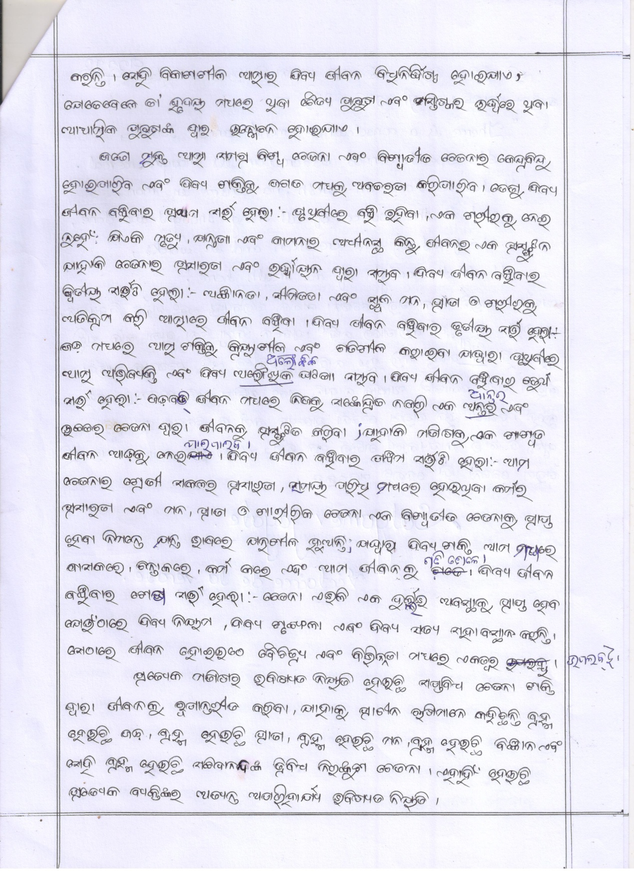

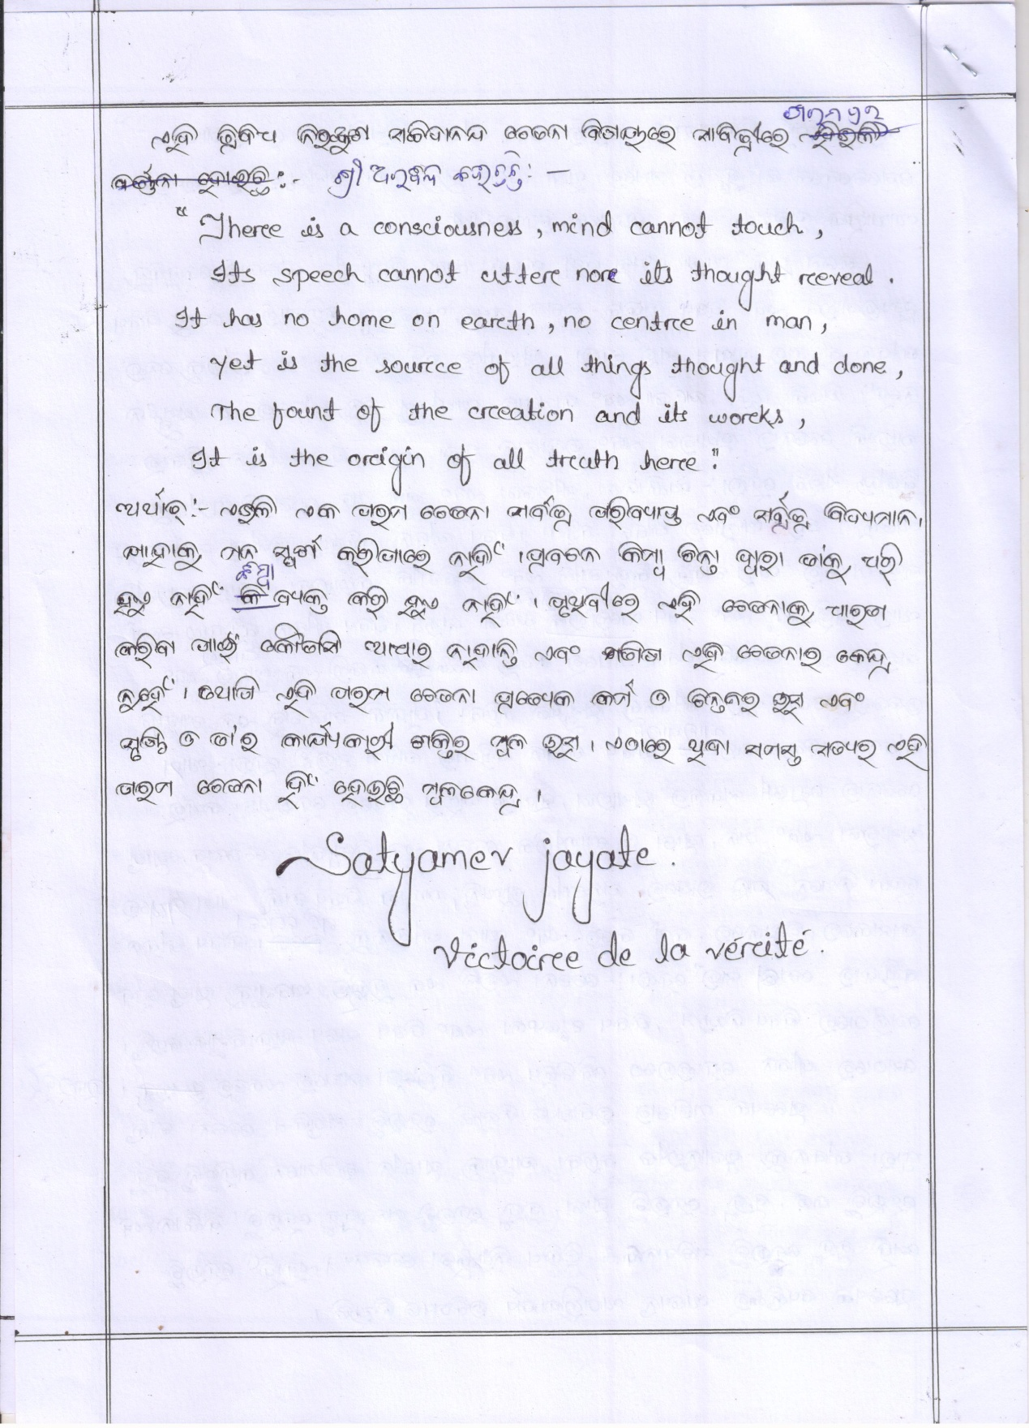

Sri Matriniketan Ashram,
Managed by The Mother’s International Centre Trust,
Regd.No-146/24.11.97. Vill: Ramachandrapur, PO: Kukudakhandi-761100,
Via: Brahmapur, Dist: Ganjam, State: Odisha, India

